MANDATORY HANDS-ON FOR WEEK-2

ADVANCED SQL

1. Ranking and Window Functions

I have created a table and inserted some objects(values).

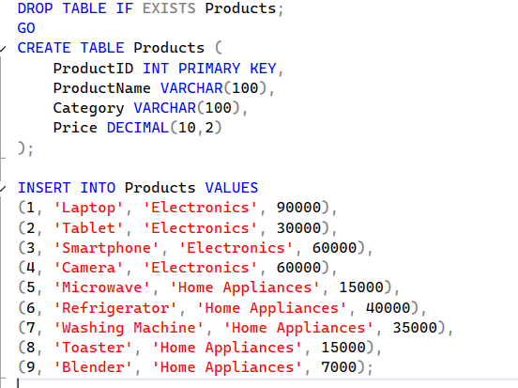

QUERY:

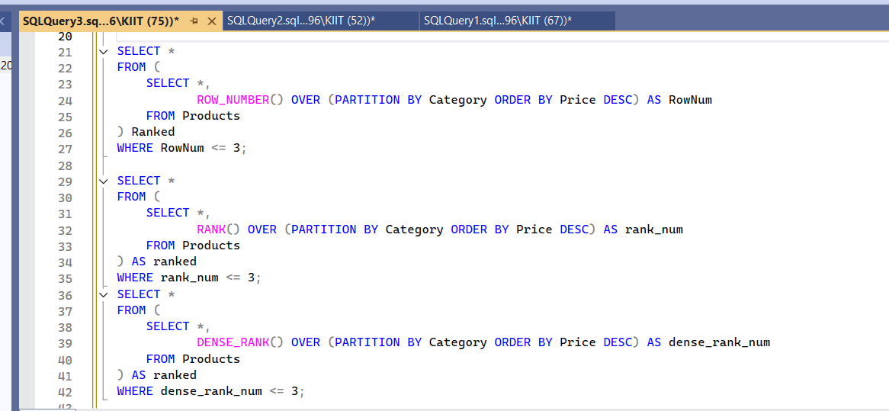

OUTPUT:

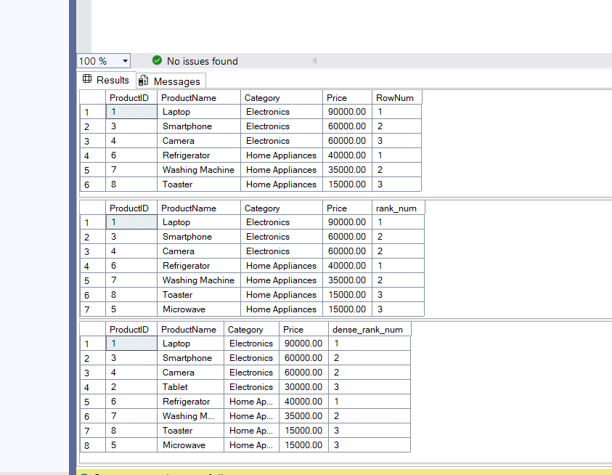

1. SQL EXERCISE-4 (STORED PROCEDURES)

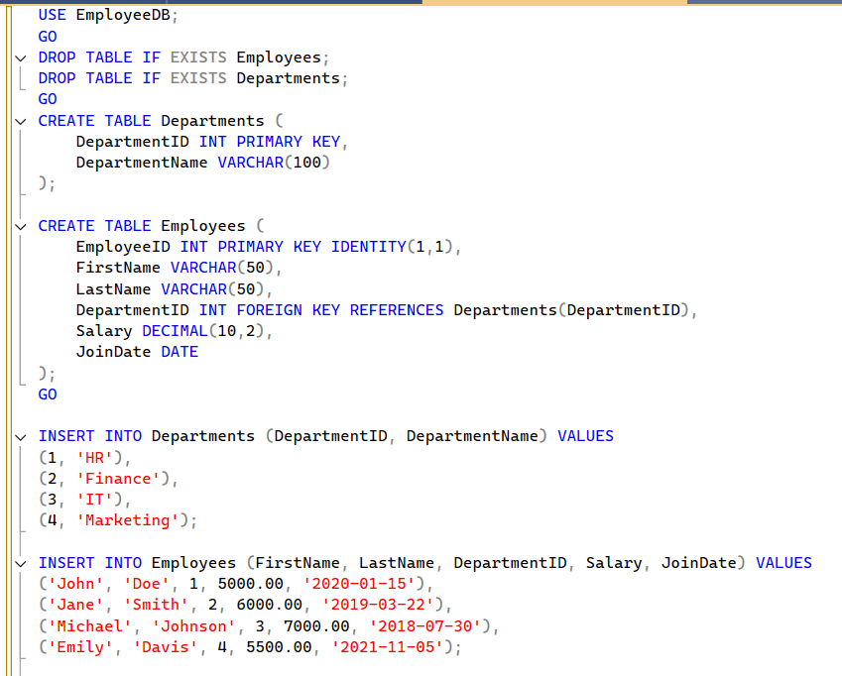

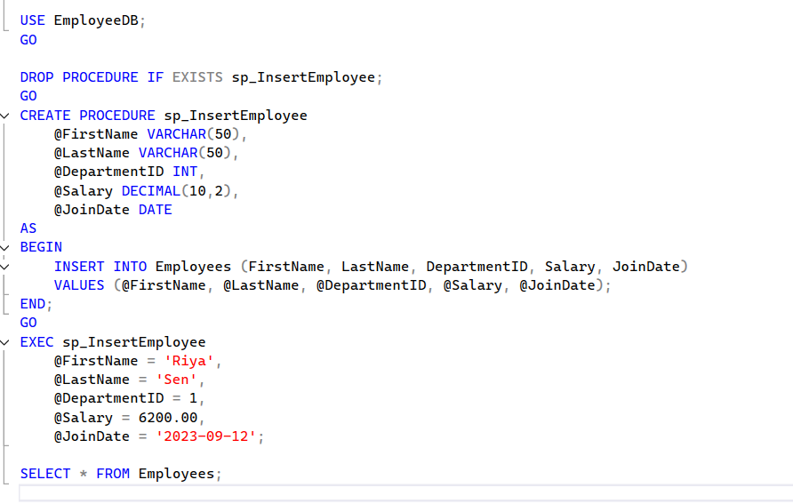

OUTPUT:

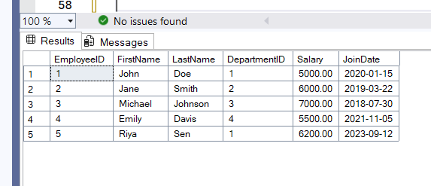

3.RETURN DATA FROM ASTOREDPROCEDURE 